5.1 4.9 4.8 5.0 4.9
4.8 4.9 4.5 4.9 4.9
3 2 4 3 3

 Are you interested in skating contests ?

 Do you wish to have the scores immediately ?

 Do you compare your skater against others after each performance ?

 Do you have a PalmPilot organiser ?

 If yes, all this is possible with:
Skalc

Skalc, a portable OBO-compliant calculator.
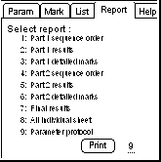
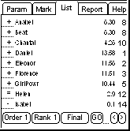
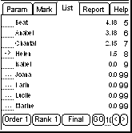
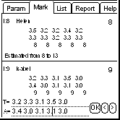
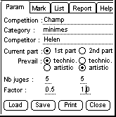

www.a2m2.ch/fred/skating fred@a2m2.ch

